FIT5125: IT Research and Innovation Methods
Assignment 2 (Task-C Report)
Name: Bharath Arun Gandhimani Student ID: 35501308

Introduction
Multilingual collaboration in video conferencing platforms like Zoom poses unique challenges that impact communication fluidity and user engagement. This report examines detailed user experiences related to multilingual interaction, aiming to identify pressing design issues and propose innovative solutions to improve inclusivity and social connection. Through affinity diagramming, key themes were synthesized from user quotes. Four design problem statements were derived to guide brainstorming of potential feature enhancements, culminating in two comprehensive design rationales supporting distinct solutions.
  - Part 1: Affinity Diagram
https://miro.com/app/board/uXjVJuQUGcg=/?share_link_id=898399489635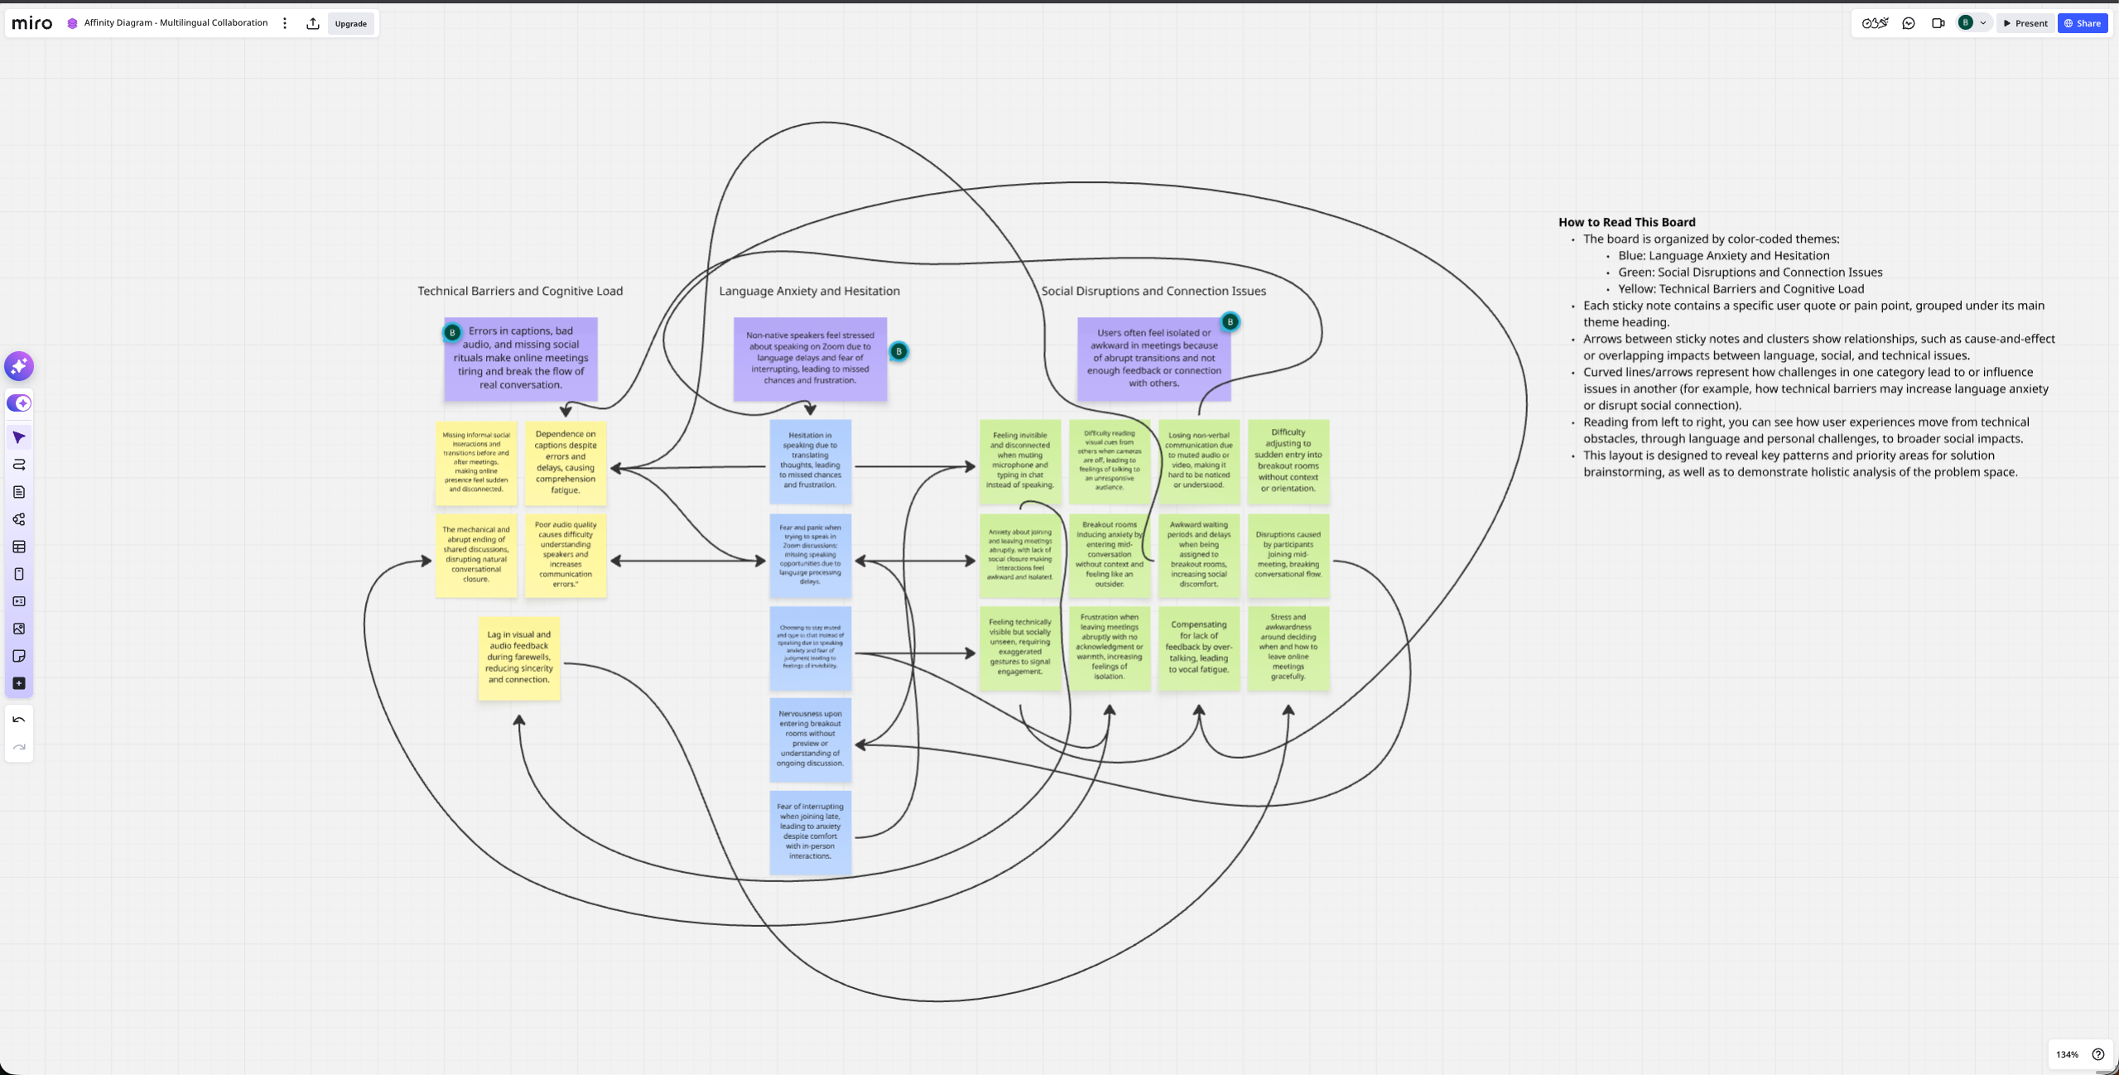

Identifying Key Themes in Multilingual Collaboration
A thorough analysis of participant quotes revealed four interconnected themes affecting multilingual users in Zoom meetings:
- Language Processing Anxiety and Hesitation:
  - Non-native speakers often face delays in forming responses, struggling to find the right words before conversation moves ahead. This timing pressure creates significant anxiety, causing many to self-censor or resort to text chat, which lacks the warmth and immediacy of spoken interaction. The phenomenon leads to a sense of invisibility and exclusion.
- Abrupt Entry and Exit Transitions:
  - In online meetings as a major point of discomfort. Participants described feeling like intruders when joining mid-discussion or feeling abruptly disconnected when calls end without natural social closure. These sudden transitions disrupt conversational flow and emotional connection, contrasting sharply with the gradual entry and exit rituals of in-person meetings.
- Deficiency of Non-Verbal and Social Cues:
  - Users noted difficulty interpreting engagement and emotional tone when cameras were off or microphones muted. The loss of facial expressions and gestures made conversations feel one-sided, creating uncertainty and necessitating exaggerated behaviors to signal attentiveness.
- Captioning, Audio Challenges, and Cognitive Load:
  - Many participants relied on captions that were often delayed or errant, while poor audio quality compounded comprehension difficulties. These technical challenges increased mental fatigue and reduced overall user satisfaction.

Formulating Design Problem Statements
Building upon these themes, the following problem statements were crafted to precisely capture the core issues and orient design efforts:
- Multilingual participants encounter exclusion due to delays and anxiety in verbal contributions, stemming from the time needed to process and translate language.
- Online meeting transitions lack the social rituals of in-person meetings, causing feelings of intrusiveness on entry and abrupt disconnection on exit.
- The absence of reliable non-verbal cues diminishes clarity and engagement, undermining social vitality in virtual communication.
- Imperfections in captioning and audio quality intensify cognitive load, eroding multilingual participants’ comprehension and comfort.
Each statement encapsulates a distinct facet of the multilingual collaboration experience, emphasizing both cognitive and social dimensions.

Brainstorming Design Solutions
In response to these challenges, a range of Zoom feature extensions and interface enhancements were explored through iterative ideation.
For language processing and anxiety, an Adaptive Speaking Cue System was proposed. This system leverages AI to monitor conversational flow, detecting natural pauses and signaling optimal moments for multilingual participants to speak. Such cues empower users to contribute confidently without interrupting, fostering equitable participation.
Addressing the abruptness of transitions, Social Rhythm Enhancement Features were designed. These include ‘soft landing’ join previews that provide context and ambient social cues, exit animations simulating natural farewells, and delayed exit visuals ensuring goodbyes are acknowledged despite lag. Together, these features smoothen transitions, restoring social warmth and continuity.
Recognizing the need for richer social cues, designs incorporating Multimodal Presence Signals were conceptualized. Visual indicators such as emphasis halos or color pulses would represent attentiveness or emotion for users with cameras off, supporting nuanced communication.
Finally, to mitigate cognitive load, proposals for Enhanced Captioning and Audio Tools were developed. These include caption tone markers conveying emotional cues, real-time translation assistance, and improved audio processing to ensure clarity and reduce fatigue.
From the range of ideas, I chose to focus on the Adaptive Speaking Cue System and Social Rhythm Enhancements because they address two important areas: language processing challenges and the social dynamics of online meetings.

Design Rationale
  - Part 2: Design Ideology Miro Board:
https://miro.com/app/board/uXjVJtqlxz4=/?share_link_id=863567332548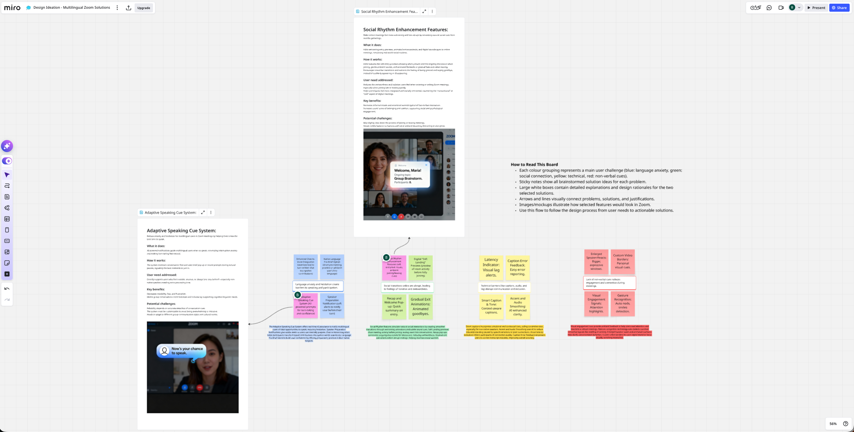

Adaptive Speaking Cue System
Communication anxiety and hesitation are among the most significant barriers faced by multilingual users in virtual meetings, such as those on Zoom. The Adaptive Speaking Cue System directly addresses this challenge by deploying AI-powered, context-aware notifications that guide turn-taking during conversations. This system continuously analyses the conversational flow, detecting natural pauses and silences that present appropriate opportunities for a user to contribute without interrupting or speaking over others. For multilingual participants who often need extra time to process and formulate responses, these cues serve as verbal permission to join the conversation with confidence, thereby reducing feelings of invisibility and exclusion.
This design is deeply rooted in the user experiences shared in the quotes, where several participants noted their hesitation to speak, fear of judgment, and the frustration of missing their chance to contribute. By equipping users with real-time visual or auditory signals indicating optimal speaking moments, the system alleviates the cognitive load of self-monitoring and turn-guessing. Moreover, it promotes equitable participation, ensuring that all voices—especially those of non-native speakers—are heard, enriching the meeting with diverse perspectives.
While the implementation holds great promise, some potential constraints must be acknowledged. AI-driven systems depend heavily on the accuracy of speech recognition and the ability to interpret conversational context, which vary with background noise, accents, and overlapping speech. Misinterpreted signals could either prematurely prompt a user to speak or cause them to miss a real opening. Additionally, some users may find automated prompts intrusive or distracting unless customizable. Adapting the system to different group dynamics and cultural communication styles also presents a challenge, as norms about interruptions and turn-taking vary widely.
Despite these limitations, the Adaptive Speaking Cue System enhances Zoom’s inclusivity by supporting a natural conversational rhythm that accounts for multilingual users’ unique cognitive and linguistic needs. This approach fosters a more supportive environment where users feel empowered to contribute, leading to richer, more dynamic interactions and stronger connection among participants.

Social Rhythm Enhancement Features
Online meetings inherently lack many of the informal social rituals that underpin natural human connection in face-to-face settings. The Social Rhythm Enhancement Features aim to restore these social cues and emotional warmth by simulating gradual entry and exit rituals, which are critical for making participants feel included and connected.
During physical meetings, arrivals are often accompanied by visual and verbal greetings that provide newcomers with social context and the opportunity to integrate smoothly. Similarly, leaving a meeting is rarely abrupt; farewells are exchanged, and participants drift out gradually. On Zoom, participants often describe feeling like intruders when joining mid-discussion and emotionally isolated when meetings end abruptly with disjointed goodbyes or technical lags. These experiences can disrupt attentional flow, increase social anxiety, and diminish participants’ sense of belonging.
The proposed features introduce a ‘soft landing’ welcome preview when joining a meeting or breakout room, displaying an ambient soundscape, a summary of ongoing discussion topics, and participant presence cues. Participants can prepare mentally and socially, easing their integration. Exit animations and delayed visual disappearance of participants replicate in-person goodbye gestures, mitigating the loneliness caused by immediate disappearance from the digital space. These subtle enhancements promote shared emotional experiences that make meetings feel less transactional and more socially meaningful.
While these enhancements may slightly increase the time taken to join or leave meetings, the benefit to social coherence and psychological comfort is substantial. There is a trade-off between efficiency and humanity, but fostering a supportive social environment in multilingual settings is crucial. It addresses feedback indicating that many users feel rushed, unseen, or disconnected, ultimately improving satisfaction and sustained engagement.
By reinforcing digital meeting etiquette and emotional connection, the Social Rhythm Enhancement Features significantly contribute to more natural and socially aware online interactions, essential for effective and inclusive multilingual collaboration.

